KOHAT UNIVERSITY OF SCIENCE AND TECHNOLOGY


Submitted by : Zahid Islam
Reg No: CS120242096
Class : OPEN B 5th Semester
Submitted to :Mam Samina amina

Project Description: Noor Bags – School Bags Website

Noor Bags is a responsive school bags website developed using HTML5 and CSS3. The website is designed to provide users with a simple, attractive, and user-friendly platform to explore different collections of school bags.
The website includes a fixed navigation bar, a hero section with an attractive background image, and navigation links such as Home, Products, About, Shop, and Contact. It features a modern layout with product cards displaying bag images, names, prices, and descriptions.
The project focuses on responsive web design, ensuring that the website can adapt to different screen sizes, including desktops, tablets, and mobile devices. It also uses CSS Grid, Flexbox, CSS positioning, hover effects, and background images to improve its appearance and usability.
Technologies Used: HTML5 and CSS3.

User interface

Desktop size ;
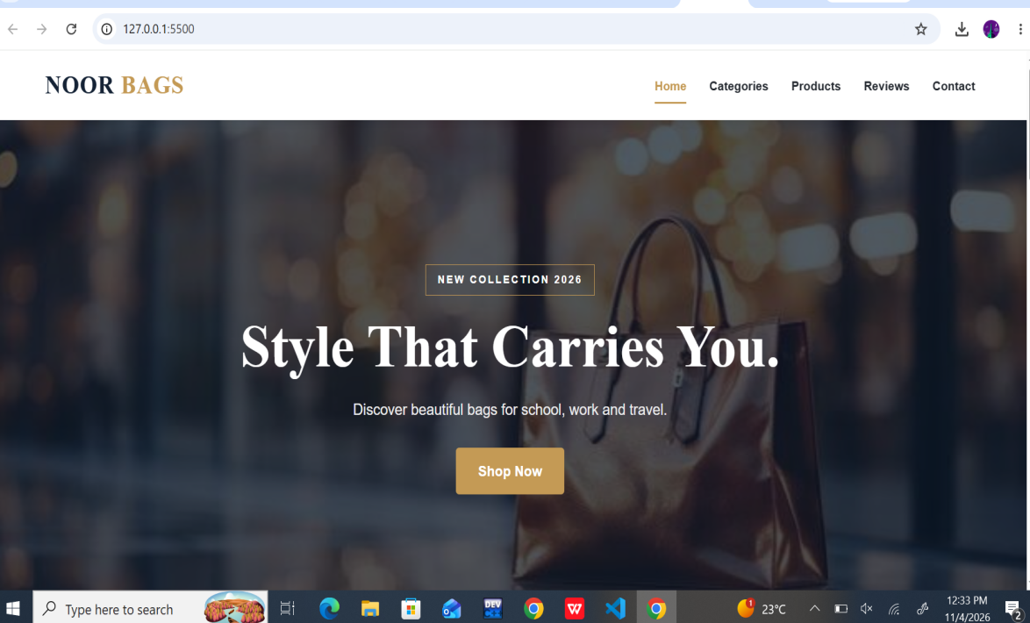

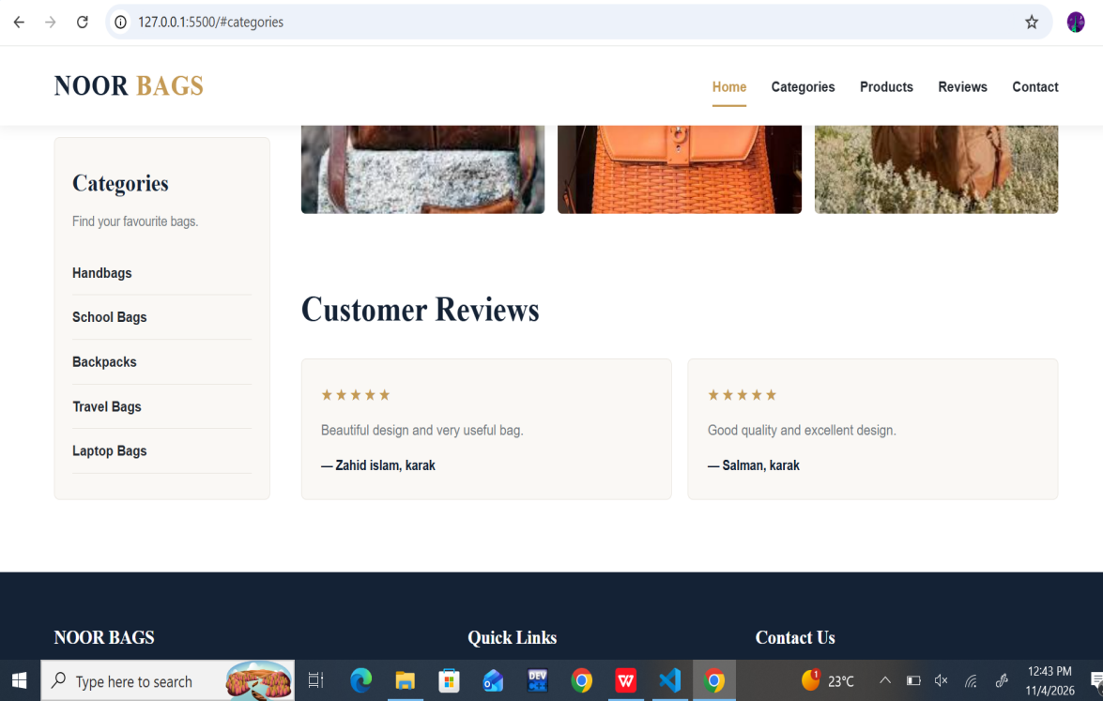

Tablet size;

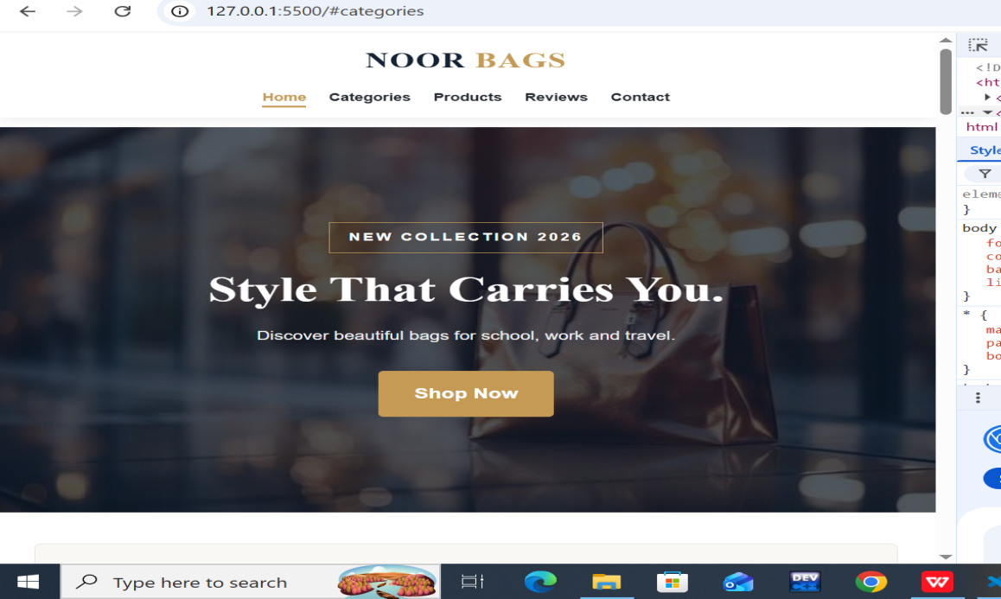
Mobile size;



